

SAMYAK-25

Event Information

Date: 10-10-2025

Department Name : CSE-3
Event Name : Front-End Security Lab
Event Date(s) : 10-10-2025
Event Duration (Hrs./Days) : 4 hours 10:00 AM to 5:30 PM (6 Hrs 30 min)
Event Venue / Room No. : C 511
Resource Person Name : Soma sekhar
Designation & Address of
Resource Person : Assistant Professor Faculty Coordinator EMP.ID : 9196
Faculty Coordinator Name : Ms. Vadduri Maneesha

Faculty Coordinator Email-ID : vaddurimaneesha@kluniversity.in
Description of the Event : Prevent common UI Vulnerabilities. Explore DOM sanitization, CSP headers, and input validation.


Geotagged Photographs of the event

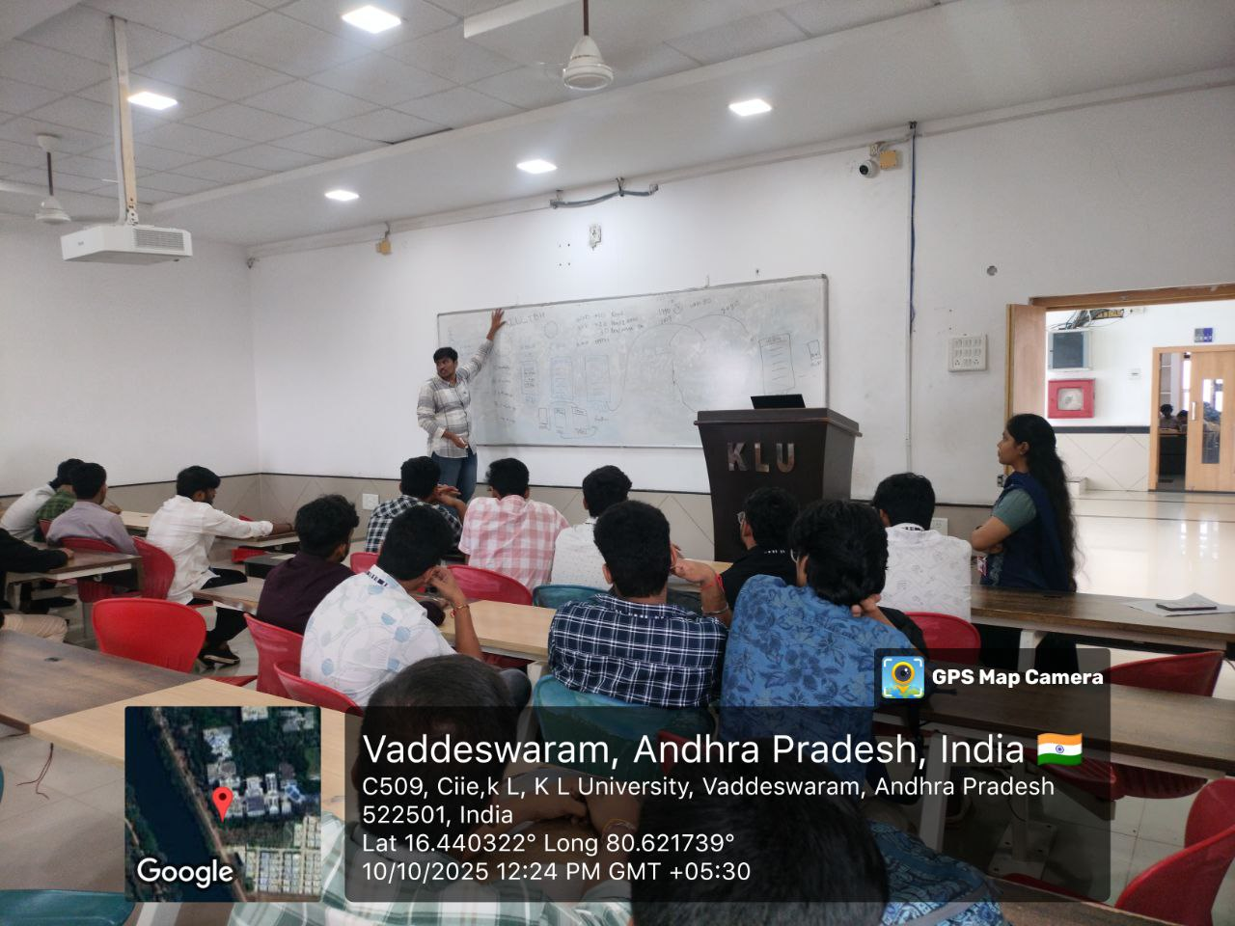
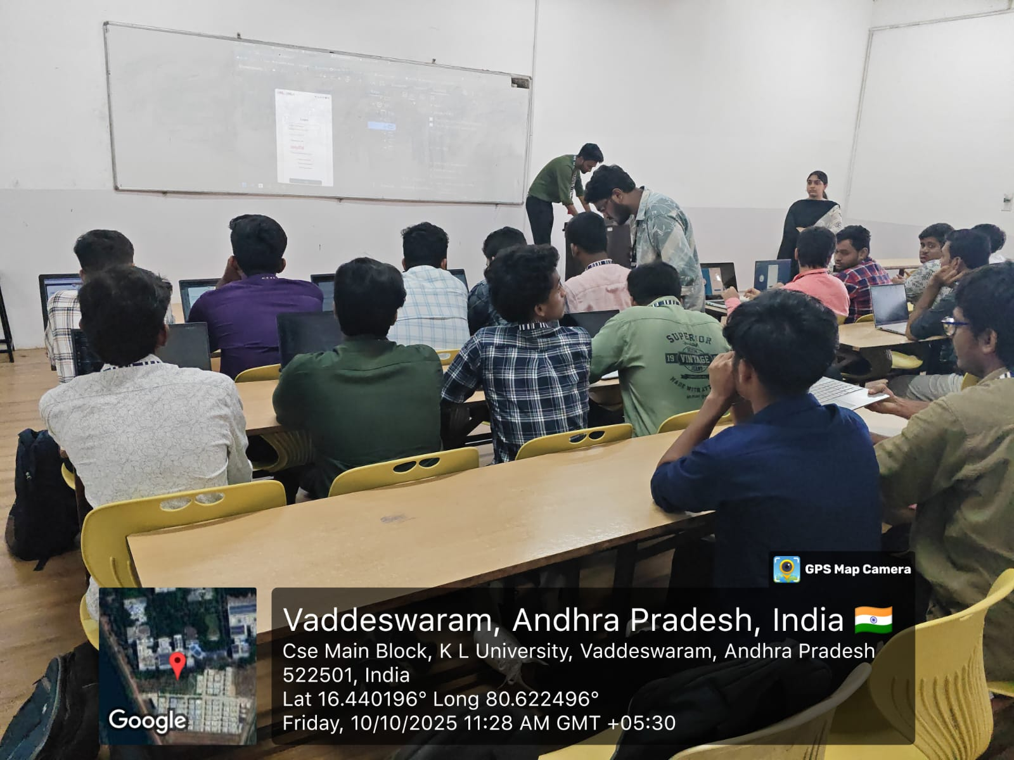

Output :

Participants gained practical experience in securing front-end web applications.
They learned how to identify and mitigate common UI vulnerabilities such as Cross-Site Scripting (XSS), improper input validation, and unsafe DOM manipulations.
Hands-on activities covered DOM sanitization, Content Security Policy (CSP) implementation, and secure form handling techniques.
By the end of the workshop, students were able to apply front-end security measures in real-time web development projects, enhancing both awareness and coding practices related to secure UI design.

ROUND 1

Screening & Theory Session:
Participants were first given an overview of front-end security concepts, including common web vulnerabilities like XSS, CSRF, and DOM-based attacks. A short screening session was conducted to assess their understanding of web fundamentals such as HTML, JavaScript, and browser behavior. This round helped identify participants with a clear grasp of UI and front-end basics to move forward into the hands-on lab

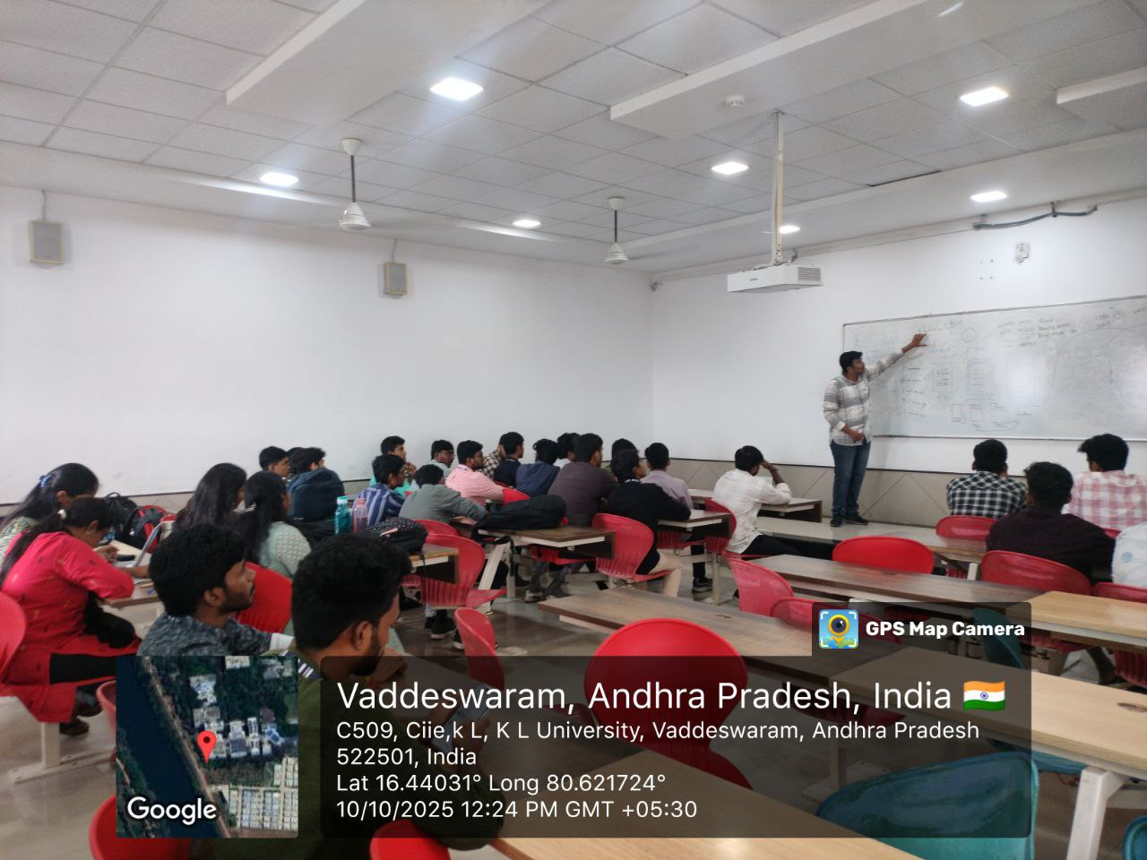

ROUND-2

Practical Implementation & Hands-on Lab:
In this round, participants performed live exercises focusing on real-world vulnerabilities and their prevention. They implemented DOM sanitization, added Content Security Policies (CSP headers), and performed input validation in web forms. The round concluded with a demonstration of secure coding techniques and best practices for building safe and reliable user interfaces.

EVENT POSTER:

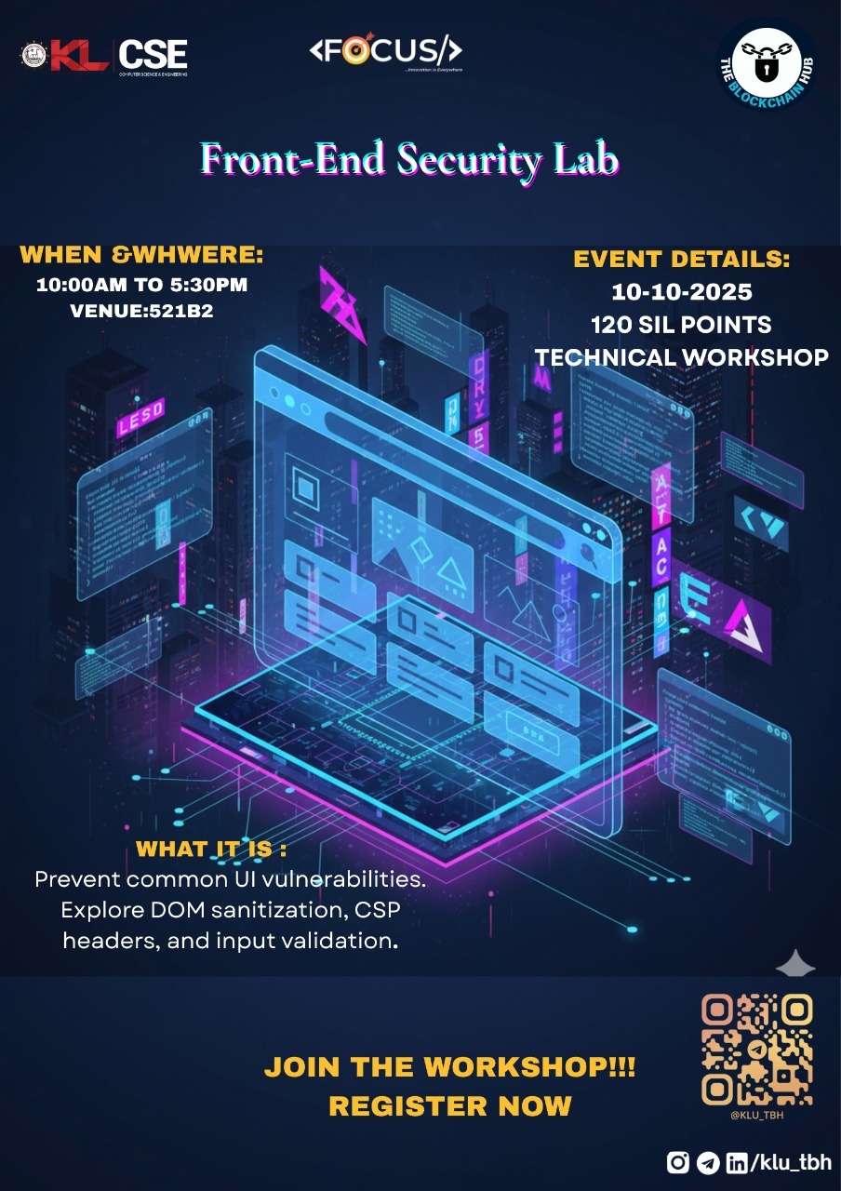

Signature of Faculty Coordinator Signature of HOD Signature of Convener
SAMYAK-25

